//PROGRAM TO STORE THE ELEMENTS IN AN ARRAY AND PRINT THEM//

#include<stdio.h>

int main()

{

int size;

printf("Enter the size of the array: ");

scanf("%d", &size);

int arr[size];

printf("Enter %d elements:\n", size);

for (int i = 0; i < size; i++)

{

scanf("%d", &arr[i]);

}

printf("Elements stored in the array:\n");

for (int i = 0; i < size; i++)

{

printf("%d ", arr[i]);

}

printf("\n");

return 0;

}

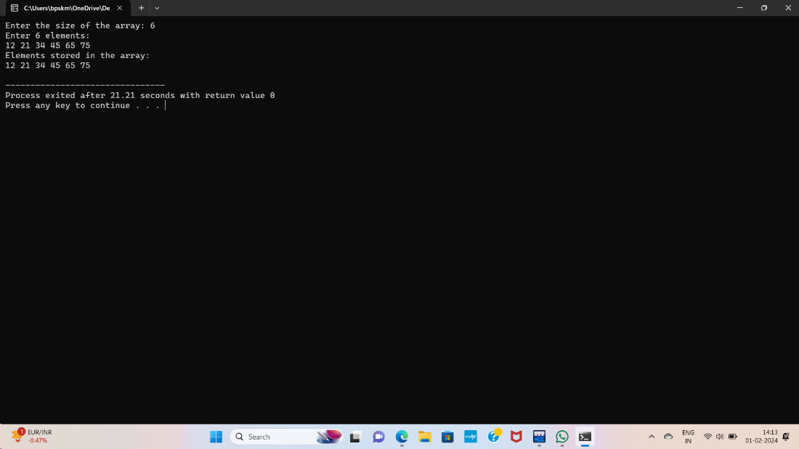

//PROGRAM TO READ n NUMBER OF ELEMENTS OF AN ARRAY AND DISPLAY THEM IN REVERSE ORDER//

#include<stdio.h>

int main() {

int n;

printf("Enter the number of values: ");

scanf("%d", &n);

int arr[n];

printf("Enter %d values:\n", n);

for (int i = 0; i < n; i++)

{

scanf("%d", &arr[i]);

}

printf("Values in reverse order:\n");

for (int i=n-1;i>=0;i--)

{

printf("%d ", arr[i]);

}

printf("\n");

return 0;

}

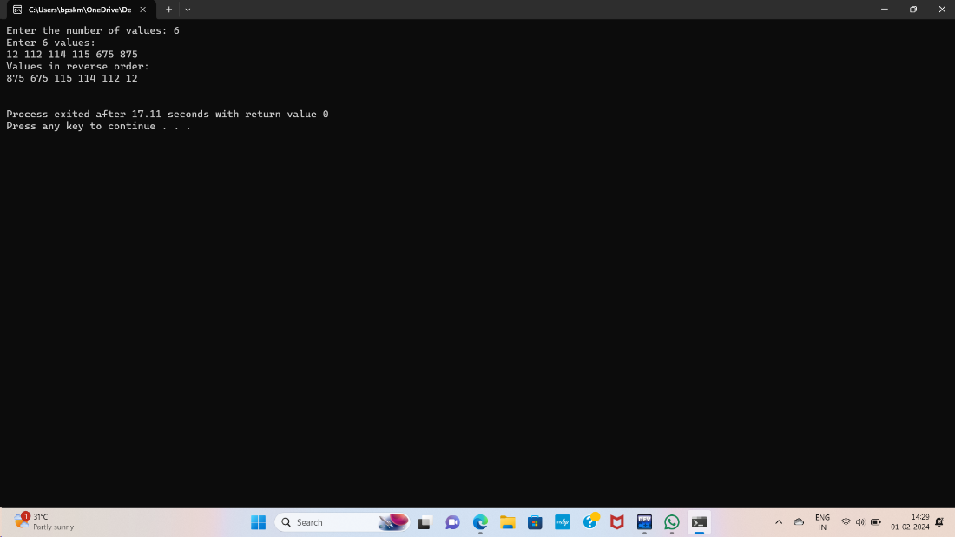

//PROGRAM TO FIND THE SUM OF ELEMENTS IN AN ARRAY//

#include<stdio.h>

int main()

{

int arr[100], size, i, sum = 0;

printf("Enter array size:");

scanf("%d",&size);

printf("Enter array elements:\n");

for(i = 0; i < size; i++)

{

scanf("%d",&arr[i]);

}

for(i = 0; i < size; i++)

{

sum = sum + arr[i];

}

printf("Sum of the array = %d\n",sum);

return 0;

}

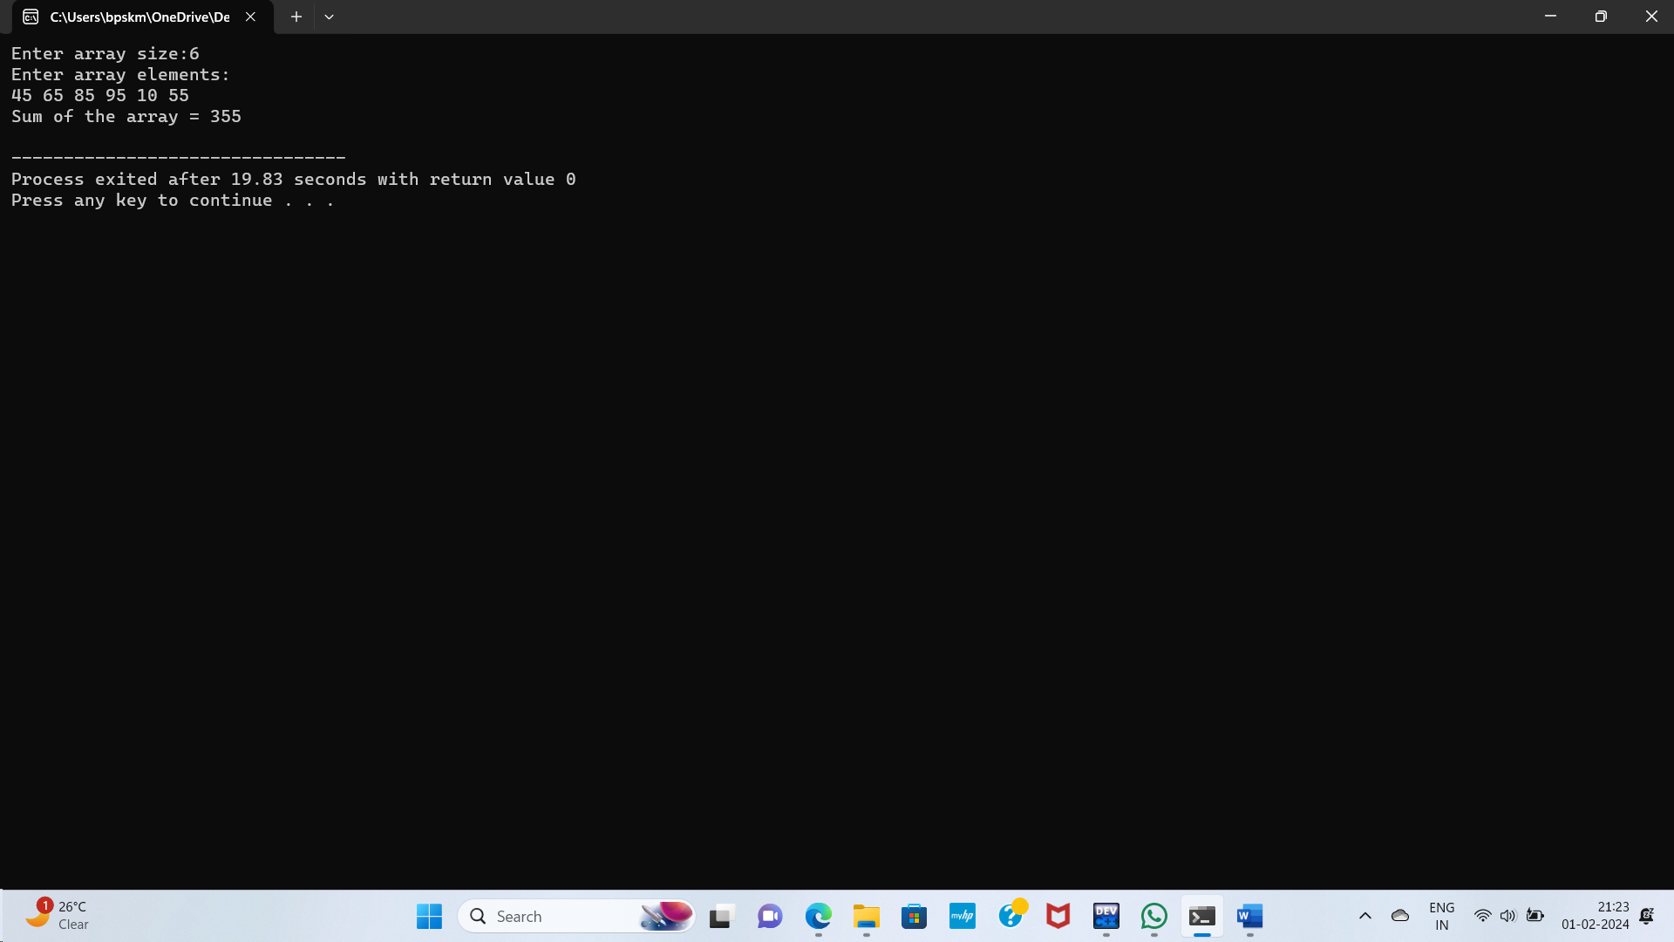

//PROGRAM TO COUNT THE TOTAL NUMBER OF DUPLICATE ELEMENTS IN AN ARRAY//

#include<stdio.h>

int main()

{

int arr[] = {43,45,65,75,6,8,9,7,7,2,3,4,8,9,10,10,1,1};

int n = sizeof(arr)/sizeof(arr[0]);

int count = 0;

for(int i=0;i<n;i++)

{

for(int j=i+1;j<n;j++)

{

if(arr[i]==arr[j])

{

count++;

printf("The duplicate numbers are:%d\n");

break;

}

}

}

printf("Total number of duplicate elements:%d\n",count);

return 0;

}

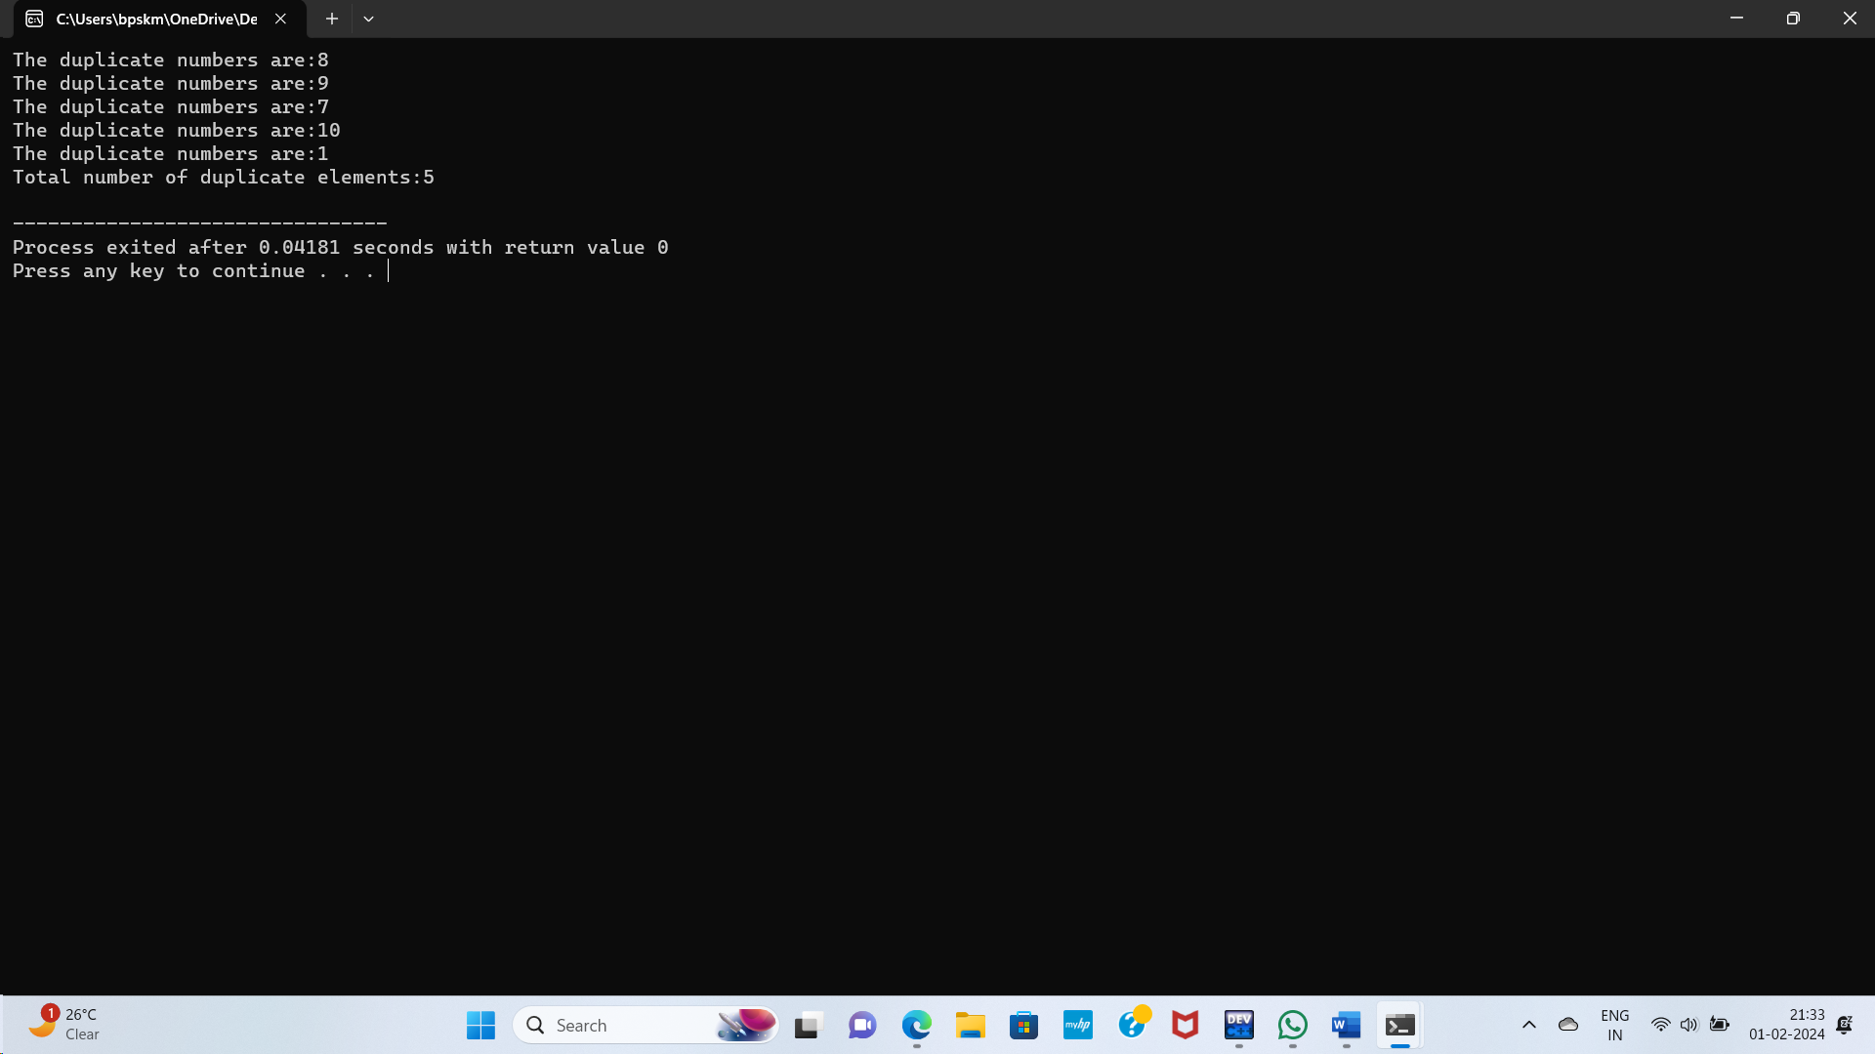

//PROGRAM TO PRINT ALL UNIQUE ELEMENTS IN AN ARRAY//

#include<stdio.h>

int main()

{

int arr[] = {45,65,75,64,45,64,80,90,80,96,45};

int n = sizeof(arr)/sizeof(arr[0]);

int Unique;

printf("Unique elements in an array:");

for(int i=0;i<n;i++)

{

Unique = 1;

for(int j=0;j<n;j++)

{

if(i!=j && arr[i]==arr[j])

{

Unique = 0;

break;

}

}

if(Unique)

{

printf("%d\n", arr[i]);

}

}

printf("\n");

return 0;

}

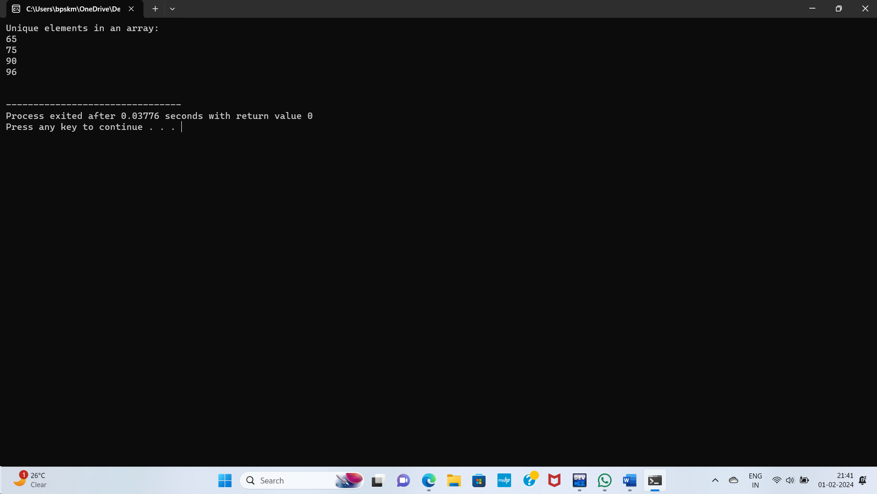

//PROGRAM TO INSERT AN ELEMENT INTO AN ARRAY//

#include<stdio.h>

#define MAX_SIZE 100

int main()

{

int arr[MAX_SIZE];

int size, element, position;

printf("Enter the size of the array:");

scanf("%d", &size);

if (size >= MAX_SIZE)

{

return 1;

}

printf("Enter elements of the array:");

for (int i = 0; i < size; i++)

{

scanf("%d", &arr[i]);

}

printf("Enter the element to insert:");

scanf("%d", &element);

printf("Enter the position to insert (0-indexed):");

scanf("%d", &position);

if (position < 0 || position > size)

{

printf("Invalid position.\n");

return 1;

}

for (int i = size; i > position; i--)

{

arr[i] = arr[i - 1];

}

arr[position] = element;

size++;

printf("Array after insertion: ");

for (int i = 0; i < size; i++)

{

printf("%d ", arr[i]);

}

printf("\n");

return 0;

}

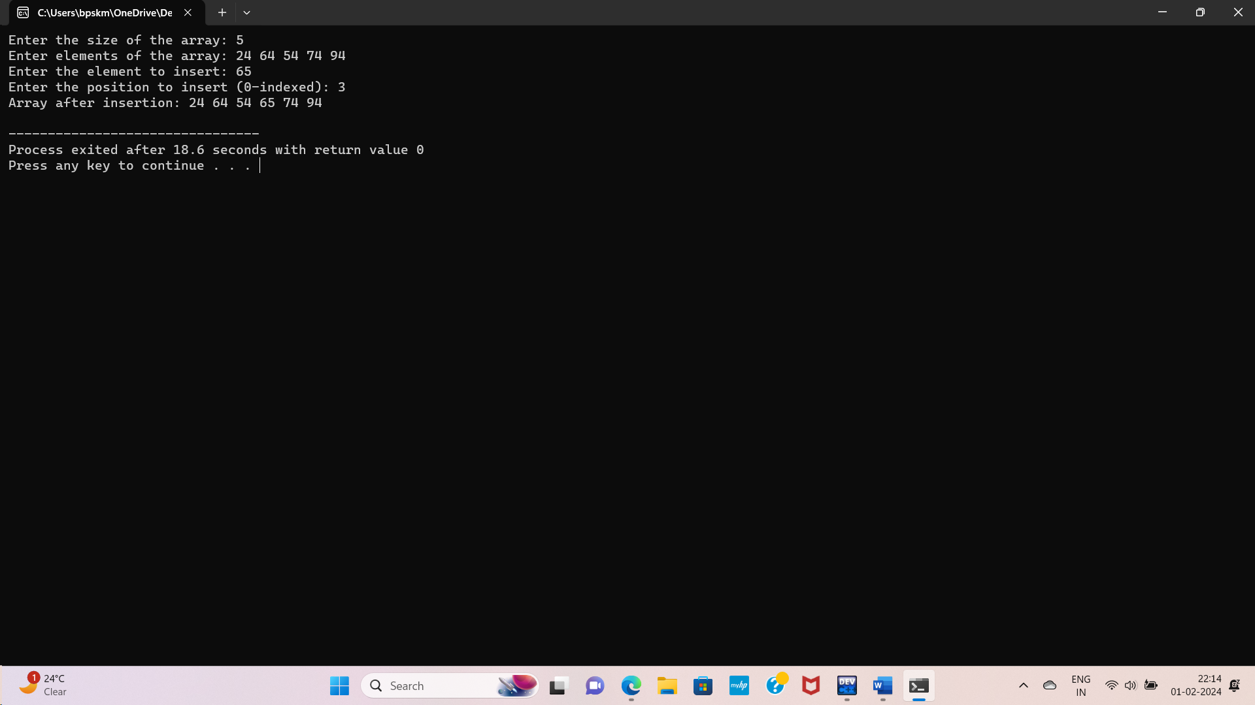

//PROGRAM TO DELETE THE ELEMENT AT THE GIVEN POSITION//

#include <stdio.h>

#define MAX_SIZE 100

int main() {

int arr[MAX_SIZE];

int size, position;

printf("Enter the size of the array: ");

scanf("%d", &size);

if (size >= MAX_SIZE)

{

printf("Array size exceeds maximum limit.\n");

return 1;

}

printf("Enter elements of the array: ");

for (int i = 0; i < size; i++)

{

scanf("%d", &arr[i]);

}

printf("Enter the position of the element to delete (0-indexed): ");

scanf("%d", &position);

if (position < 0 || position >= size)

{

printf("Invalid position.\n");

return 1;

}

for (int i = position; i < size - 1; i++)

{

arr[i] = arr[i + 1];

}

size--;

printf("Array after deletion: ");

for (int i = 0; i < size; i++) {

printf("%d ", arr[i]);

}

printf("\n");

return 0;

}

